UNITED STATES
SECURITIES AND EXCHANGE COMMISSION
WASHINGTON, D.C. 20549

FORM 8-K

CURRENT REPORT
Pursuant to Section 13 or 15(d) of the Securities Exchange Act of 1934
Date of Report (Date of earliest event reported): September 03, 2026

Duluth Holdings Inc.
(Exact name of Registrant as Specified in Its Charter)

Wisconsin |  |  | 001-37641 | 39-1564801
(State or Other Jurisdiction  of Incorporation) |  |  | (Commission File Number) | (IRS Employer  Identification No.)
201 East Front Street
Mount Horeb, Wisconsin |  |  |  | 53572
(Address of Principal Executive Offices) |  |  |  | (Zip Code)

Registrant’s Telephone Number, Including Area Code: 608 424-1544

(Former Name or Former Address, if Changed Since Last Report)

Check the appropriate box below if the Form 8-K filing is intended to simultaneously satisfy the filing obligation of the registrant under any of the following provisions:
☐Written communications pursuant to Rule 425 under the Securities Act (17 CFR 230.425)
☐Soliciting material pursuant to Rule 14a-12 under the Exchange Act (17 CFR 240.14a-12)
☐Pre-commencement communications pursuant to Rule 14d-2(b) under the Exchange Act (17 CFR 240.14d-2(b))
☐Pre-commencement communications pursuant to Rule 13e-4(c) under the Exchange Act (17 CFR 240.13e-4(c))
Securities registered pursuant to Section 12(b) of the Act:
Title of each class |  | Trading  Symbol(s) |  | Name of each exchange on which registered
Class B Common Stock, No Par Value |  | DLTH |  | Nasdaq Global Select Market
Indicate by check mark whether the registrant is an emerging growth company as defined in Rule 405 of the Securities Act of 1933 (§ 230.405 of this chapter) or Rule 12b-2 of the Securities Exchange Act of 1934 (§ 240.12b-2 of this chapter).
Emerging growth company ☐
If an emerging growth company, indicate by check mark if the registrant has elected not to use the extended transition period for complying with any new or revised financial accounting standards provided pursuant to Section 13(a) of the Exchange Act. ☐

1

Item 2.02. Results of Operations and Financial Conditions.

On September 3, 2026, Duluth Holdings Inc. (the “Company” or “Duluth Trading”) issued a press release (the “Earnings Press Release”) discussing, among other things, its financial results for its fiscal second quarter ended August 2, 2026. A copy of the Earnings Press Release is furnished as Exhibit 99.1 to this report.
Item 7.01. Regulation FD Disclosure.
On September 3, 2026, the Company issued an Investor Presentation. A copy of the Investor Presentation is attached as Exhibit 99.2 and is incorporated by reference herein.

The information reported in Items 2.02 and 7.01 of this Form 8-K, including Exhibits 99.1 and 99.2, is not deemed “filed” for the purposes of Section 18 of the Securities Exchange Act of 1934, or otherwise subject to the liabilities of that section. Further, the information reported in Items 2.02 and 7.01 of this Form 8-K, including the Exhibits 99.1 and 99.2, shall not be deemed to be incorporated by reference into the filings of the registrant under the Securities Act of 1933, as amended, except as shall be expressly set forth by specific reference in such filings.
Forward Looking Information
Certain matters discussed in this Current Report on Form 8-K and other oral and written statements by representatives of the Company including, but not limited to, the Company’s ability to meet its fiscal 2026 expectations (including its ability to achieve its projected net sales and adjusted EBITDA) and its ability to execute on its growth strategies and its long-term growth targets, are forward-looking statements within the meaning of the Private Securities Litigation Reform Act of 1995. You can identify forward-looking statements by the use of words such as “may,” “might,” “will,” “should,” “expect,” “plan,” “anticipate,” “could,” “believe,” “estimate,” “project,” “target,” “predict,” “intend,” “future,” “budget,” “goals,” “potential,” “continue,” “design,” “objective,” “forecasted,” “would,” and other similar expressions. The forward-looking statements are not historical facts, and are based upon Duluth Trading’s current expectations, beliefs, estimates, and projections, and various assumptions, many of which, by their nature, are inherently uncertain and beyond Duluth Trading’s control. Duluth Trading’s expectations, beliefs and projections are expressed in good faith, and Duluth Trading believes there is a reasonable basis for them. However, there can be no assurance that management’s expectations, beliefs, estimates, and projections will be achieved and actual results may vary materially from what is expressed in or indicated by the forward-looking statements. Forward-looking statements are subject to risks and uncertainties that could cause actual performance or results to differ materially from those expressed in the forward-looking statements, including, among others, the risks, uncertainties, and factors set forth under Part 1, Item 1A “Risk Factors” in the Company’s Annual Report on Form 10-K filed with the SEC on March 20, 2026 and other factors as may be periodically described in Duluth Trading’s subsequent filings with the SEC. These risks and uncertainties include, but are not limited to, the following: the impact of inflation and measures to control inflation on our results of operations; the prolonged effects of economic uncertainties on store and website traffic; the susceptibility of the price and availability of our merchandise to international trade conditions including tariffs; changes in U.S. and non-U.S. laws affecting the importation and taxation of goods, including imposition of unilateral tariffs on imported goods; our ability to secure the personal and/or financial information of our customers and employees; disruptions to our distribution network, supply chains and operations; failure to effectively manage inventory levels; our ability to maintain and enhance a strong brand and sub-brand image; adapting to declines in consumer confidence, inflation and decreases in consumer spending; disruptions to our e-commerce platform; our ability to meet customer delivery time expectations; our ability to properly allocate inventory throughout our distribution network to fulfill customer demand; our failure to meet our debt covenant ratios; natural disasters, unusually adverse weather conditions, boycotts, prolonged public health crises, epidemics or pandemics and unanticipated events; generating adequate cash from our existing stores and direct sales to support our growth; the impact of changes in corporate tax regulations and sales tax; identifying and responding to new and changing customer preferences; the success of the locations in which our stores are located; effectively relying on sources for merchandise located in foreign markets; transportation delays and interruptions, including port congestion; our inability to timely and effectively obtain shipments of products from our suppliers and deliver merchandise to our customers; the inability to maintain the performance of our maturing store portfolio; our inability to deploy marketing tactics and commit adequate resources to support marketing in order to retain and attract new customers; our ability to successfully open new stores; effectively adapting to new challenges associated with our expansion into new geographic markets; competing effectively in an environment of intense competition or elevated promotions; our ability to adapt to significant changes in sales due to the seasonality of our business; price reductions or inventory shortages resulting from failure to purchase the appropriate amount of inventory in advance of the season in which it will be sold; the potential for further increases in price and lack of availability of raw materials; our dependence on third-party vendors to provide us with sufficient quantities of merchandise at acceptable prices; failure of our vendors and their manufacturing sources to use acceptable labor or other practices; our dependence upon key executive management or our inability to hire or retain the talent required for our business; increases in costs of fuel or other energy, transportation or utility costs and in the costs of labor and employment; failure of our information technology systems to support our current and growing business, before and
2

after our planned upgrades; disruptions in our supply chain and fulfillment centers; our inability to protect our trademarks or other intellectual property rights; infringement on the intellectual property of third parties; acts of war, terrorism or civil unrest; the impact of governmental laws and regulations and the outcomes of legal proceedings; failure to comply with data privacy regulation; our ability to comply with the security standards for the credit card industry; our failure to maintain adequate internal controls over our financial and management systems; acquisition, disposition, and development risks; and other factors that may be disclosed in our SEC filings or otherwise. Forward-looking statements speak only as of the date the statements are made. Duluth Trading assumes no obligation to update forward-looking statements to reflect actual results, subsequent events or circumstances or other changes affecting forward-looking information except to the extent required by applicable securities laws.

Item 9.01. Financial Statements and Exhibits.
(d) Exhibits.

The following exhibits are being furnished with this Current Report on Form 8-K.

Exhibit No. |  | Exhibit Description
99.1 |  | Earnings Press Release, dated September 3, 2026
99.2 |  | Investor Presentation, dated September 3, 2026
104 |  | Cover Page interactive data (embedded with the inline XBRL document)

3

SIGNATURES
Pursuant to the requirements of the Securities Exchange Act of 1934, the registrant has duly caused this report to be signed on its behalf by the undersigned hereunto duly authorized.
 |  |  | DULUTH HOLDINGS INC.
Date: | September 3, 2026 | By: | /s/ Heena Agrawal
 |  | Name: | Heena Agrawal
 |  | Title: | Senior Vice President and Chief Financial Officer

4

Exhibit 99.1



Duluth Holdings Inc. Announces Second Quarter 2026 Financial Results

Net Income improvement over prior year driven by gross margin expansion

Continued improvement in working capital driven by a 15.5% reduction in inventory

Strong balance sheet with approximately $96 million of net liquidity and zero debt on the Asset Based Lending facility

MOUNT HOREB, WI – September 3, 2026 – Duluth Holdings Inc. (dba, Duluth Trading Company) (“Duluth Trading” or the “Company”) (NASDAQ: DLTH), a lifestyle brand of men’s and women’s workwear, casual wear, outdoor apparel and accessories, today announced its financial results for the fiscal Second Quarter ended August 2, 2026.

Summary of the Second Quarter ended August 2, 2026

●
Net income of $18.4 million compared to net income of $1.3 million in the prior year second quarter. This includes the impact of $16.3 million in tariff refunds.
●
Reported and adjusted EPS1 of $0.50. This includes a $0.44 impact from tariff refunds.
●
Adjusted EBITDA2 of $27.0 million compared to $12.0 million in the prior year second quarter. This includes the impact of $16.3 million in tariff refunds.
●
Inventory down $22.9 million or 15.5% vs. last year.
●
Cash and cash equivalents of $26.8 million with net liquidity of $96.1 million.

1See Reconciliation of net income to adjusted net income and EPS to adjusted EPS in the accompanying financial tables.
2See Reconciliation of net income to EBITDA and EBITDA to Adjusted EBITDA in the accompanying financial tables.

Management Commentary

President and CEO Stephanie Pugliese stated, “Our second quarter performance demonstrates strong execution of our operational priorities, inventory discipline, and successful promotional reset. By combining gross margin expansion with effective inventory management, we have delivered another quarter of improved profitability and free cash flow. Our core products continue to lead the way with customers responding favorably to our high-quality, solution-based workwear.”  Pugliese added, “As we enter the second half of the year, we are excited about our enhanced product offering including our new Hellbent work pants, No Quit utility shirts, and Heirloom prints. We remain focused in advancing our ‘Build to Last’ strategy, maximizing channel productivity, and consistently delivering an exceptional customer experience.”  Operating Results for the Second Quarter ended August 2, 2026  Net sales decreased by $10.3 million, or 7.8%, to $121.4 million for the three months ended August 2, 2026 compared to $131.7 million in the three months ended August 3, 2025. Direct-to-consumer net sales decreased by 11.5% to $70.1 million due to declines in web traffic and web conversion as a result of reduced promotional activity partially offset by higher average order values. Retail store net sales decreased by 2.4% to $51.3 | 

million driven by lower traffic, partially offset by higher average order values in comparable stores, coupled with two new stores opened in the third quarter of 2025.
Gross margin expanded by 1,810 basis points to 72.8% of net sales in the three months ended August 2, 2026, compared to 54.7% of net sales in the three months ended August 3, 2025. We recorded a reduction to cost of goods sold of $16.0 million related to refunds of previously incurred tariff charges. Excluding the impact of tariff refunds, gross margin was 59.6% in the three months ended August 2, 2026, an expansion of 490 basis points compared to the prior year. This increase in gross margin rate was primarily driven by an increase in average unit retail prices from reduced promotional activity, coupled with an improvement in product costs from our direct to factory sourcing initiative.
Selling, general and administrative expenses increased $0.7 million, or 1.1%, to $69.5 million in the three months ended August 2, 2026 compared to $68.8 million in the three months ended August 3, 2025. Selling, general and administrative expenses as a percentage of net sales increased by 510 basis points to 57.3% in the three months ended August 2, 2026, compared to 52.2% in the three months ended August 3, 2025. The increase in selling, general and administrative expenses as a percentage of net sales was mainly driven by an increase in advertising and shipping expenses, which was partially offset by leverage in variable expenses in our fulfillment centers and stores coupled with lower overhead expenses.

Balance Sheet and Liquidity

The Company ended the quarter with $26.8 million of cash and cash equivalents, $85.7 million of net working capital, and zero outstanding debt on the $70.0 million Asset Based Lending facility resulting in approximately $96 million of net liquidity.

Fiscal 2026 Outlook

For Fiscal 2026, the Company is:
●
Affirming previously issued fiscal 2026 net sales guidance range of $540 million to $560 million
●
Raising previously issued fiscal 2026 Adjusted EBITDA1 guidance to $38 million to $42 million compared to the previous guidance of $28 million to $32 million, including the impact of tariff refunds
●
Affirming capital expenditures, inclusive of software hosting implementation costs, of approximately $12 million

1See Reconciliation of Forecasted Net Income to Forecasted EBITDA and Forecasted EBITDA to Forecasted Adjusted EBITDA in the accompanying financial tables.

Conference Call Information
A conference call and audio webcast with analysts and investors will be held on Thursday, September 3, 2026, at 9:30 am Eastern Time to discuss the results and answer questions.
Links to access earnings information:
●
Live Webcast: https://edge.media-server.com/mmc/p/ikonm7ds/
●
Live Call: https://register-conf.media-server.com/register/BI318a2d17c9bf472ab0e924ba22a6be55
●
Webcast Archive: https://ir.duluthtrading.com/news-and-events/event-calendar
About Duluth Trading
Duluth Trading is a lifestyle brand for the Modern, Self-Reliant American. Based in Mount Horeb, Wisconsin, we offer high quality, solution-based workwear, casual wear, outdoor apparel and accessories for men and women who lead a hands-on lifestyle and who value a job well-done. We provide our customers an engaging and entertaining experience. Our marketing incorporates humor and storytelling that conveys the uniqueness of our products in a distinctive, fun way, and are available through our content-rich website, catalogs, and “store like no other” retail locations. We are committed to outstanding customer service backed by our “No Bull Guarantee” - if it’s not right, we’ll fix it. Visit our website at http://www.duluthtrading.com.

Non-GAAP Measurements

Management believes that non-GAAP financial measures may be useful in certain instances to provide additional meaningful comparisons between current results and results in prior operating periods. Within this release, including the tables attached hereto, reference is made to adjusted earnings before interest, taxes, depreciation and amortization (EBITDA), Adjusted Net Income (Loss), Adjusted EPS, and Forecasted Adjusted EBITDA. See attached table “Reconciliation of Net Income (Loss) to EBITDA and EBITDA to Adjusted EBITDA,” for a reconciliation of net income (loss) to EBITDA and EBITDA to Adjusted EBITDA and “Reconciliation of

Net Income (Loss) to Adjusted Net Income (Loss) and EPS to Adjusted EPS” for a reconciliation of net income (loss) to adjusted net income (loss) and EPS to adjusted EPS for the three and six months ended August 2, 2026 and August 3, 2025. Also see attached table “Reconciliation of Forecasted Net Income (Loss) to Forecasted EBITDA and Forecasted EBITDA to Forecasted Adjusted EBITDA” for a reconciliation of forecasted Adjusted EBITDA for Fiscal 2026.

Adjusted EBITDA is a metric used by management and frequently used by the financial community, which provides insight into an organization’s operating trends and facilitates comparisons between peer companies, since interest, taxes, depreciation and amortization can differ greatly between organizations as a result of differing capital structures and tax strategies. Adjusted EBITDA excludes certain other items, which include significant non-cash items, and other charges or benefits resulting from transactions or events that are highly variable, significant in size, and that we do not believe are indicative of ongoing or future business operations.

Adjusted Net Income (Loss) and Adjusted EPS are metrics used by management and frequently used by the financial community, which provides insight into the effectiveness of our business strategies and to compare our performance against that of peer companies. Adjusted Net Income (Loss) and Adjusted EPS exclude restructuring expenses and impairment expenses that are not comparable from period to period.

The Company provides this information to investors to assist in comparisons of past, present and future operating results and to assist in highlighting the results of on-going operations. While the Company’s management believes that non-GAAP measurements are useful supplemental information, such adjusted results are not intended to replace the Company’s GAAP financial results and should be read in conjunction with those GAAP results.
Forward-Looking Statements

This press release includes “forward-looking statements” within the meaning of the Private Securities Litigation Reform Act of 1995. All statements, other than statements of historical facts included in this press release, including statements concerning Duluth Trading’s plans, objectives, goals, beliefs, business strategies, future events, business conditions, its results of operations, financial position and its business outlook, business trends and certain other information herein, including statements under the heading “Fiscal 2026 Outlook” are forward-looking statements. You can identify forward-looking statements by the use of words such as “may,” ”might,” “will,” “should,” “expect,” “plan,” “anticipate,” “could,” “believe,” “estimate,” “project,” “target,” “predict,” “intend,” “future,” “budget,” “goals,” “potential,” “continue,” “design,” “objective,” “forecasted,” “would” and other similar expressions. The forward-looking statements are not historical facts, and are based upon Duluth Trading’s current expectations, beliefs, estimates, and projections, and various assumptions, many of which, by their nature, are inherently uncertain and beyond Duluth Trading’s control. Duluth Trading’s expectations, beliefs and projections are expressed in good faith, and Duluth Trading believes there is a reasonable basis for them. However, there can be no assurance that management’s expectations, beliefs, estimates, and projections will be achieved and actual results may vary materially from what is expressed in or indicated by the forward-looking statements. Forward-looking statements are subject to risks and uncertainties that could cause actual performance or results to differ materially from those expressed in the forward-looking statements, including, among others, the risks, uncertainties, and factors set forth under Part 1, Item 1A “Risk Factors” in the Company’s Annual Report on Form 10-K filed with the SEC on March 20, 2026 and other factors as may be periodically described in Duluth Trading’s subsequent filings with the SEC. These risks and uncertainties include, but are not limited to, the following: the impact of inflation and measures to control inflation on our results of operations; the prolonged effects of economic uncertainties on store and website traffic; the susceptibility of the price and availability of our merchandise to international trade conditions including tariffs; changes in U.S. and non-U.S. laws affecting the importation and taxation of goods, including imposition of unilateral tariffs on imported goods; our ability to secure the personal and/or financial information of our customers and employees; disruptions to our distribution network, supply chains and operations; failure to effectively manage inventory levels; our ability to maintain and enhance a strong brand and sub-brand image; adapting to declines in consumer confidence, inflation and decreases in consumer spending; disruptions to our e-commerce platform; our ability to meet customer delivery time expectations; our ability to properly allocate inventory throughout our distribution network to fulfill customer demand; our failure to meet our debt covenant ratios; natural disasters, unusually adverse weather conditions, boycotts, prolonged public health crises, epidemics or pandemics and unanticipated events; generating adequate cash from our existing stores and direct sales to support our growth; the impact of changes in corporate tax regulations and sales tax; identifying and responding to new and changing customer preferences; the success of the locations in which our stores are located; effectively relying on sources for merchandise located in foreign markets; transportation delays and interruptions, including port congestion; our inability to timely and effectively obtain shipments of products from our suppliers and deliver merchandise to our customers; the inability to maintain the performance of our maturing store portfolio; our inability to deploy marketing tactics and commit adequate resources to support marketing in order to retain and attract new customers; our ability to successfully open new stores; effectively adapting to new challenges associated with our expansion into new geographic markets; competing effectively in an environment of intense competition or elevated promotions; our ability to adapt to significant changes in sales due to the seasonality of our business; price reductions or inventory shortages resulting from failure to purchase the appropriate amount of inventory in advance of the season in which it will be sold; the potential for further increases in price and lack of availability of raw materials; our dependence on third-party vendors to provide us with sufficient quantities of merchandise at acceptable prices; failure of our vendors and their manufacturing sources to use acceptable labor or other practices; our dependence upon key executive management or our inability to hire or retain the talent required for our business; increases in costs of fuel or other energy, transportation or utility costs and in the costs of labor and employment; failure of our information technology

systems to support our current and growing business, before and after our planned upgrades; disruptions in our supply chain and fulfillment centers; our inability to protect our trademarks or other intellectual property rights; infringement on the intellectual property of third parties; acts of war, terrorism or civil unrest; the impact of governmental laws and regulations and the outcomes of legal proceedings; failure to comply with data privacy regulation; our ability to comply with the security standards for the credit card industry; our failure to maintain adequate internal controls over our financial and management systems; acquisition, disposition, and development risks; and other factors that may be disclosed in our SEC filings or otherwise. Forward-looking statements speak only as of the date the statements are made. Duluth Trading assumes no obligation to update forward-looking statements to reflect actual results, subsequent events or circumstances or other changes affecting forward-looking information except to the extent required by applicable securities laws.

Investor Contacts:
Heena Agrawal
Senior Vice President and Chief Financial Officer

Chris Steffes
Senior Director of Financial Planning and Analysis

Email: IR@duluthtrading.com

(Tables Follow)
***

DULUTH HOLDINGS INC.
Condensed Consolidated Balance Sheets
(Unaudited)
(Amounts in thousands)

 |  | August 2, 2026 |  |  |  | February 1, 2026 |  |  |  | August 3, 2025
ASSETS
Current assets:
Cash and cash equivalents |  | $ | 26,799 |  |  | $ | 16,345 |  |  | $ | 5,738
Receivables |  |  | 2,127 |  |  |  | 2,710 |  |  |  | 8,894
Inventory, net |  |  | 125,152 |  |  |  | 131,342 |  |  |  | 148,051
Prepaid expenses & other current assets |  |  | 28,863 |  |  |  | 21,654 |  |  |  | 23,249
Total current assets |  |  | 182,941 |  |  |  | 172,051 |  |  |  | 185,932
Property and equipment, net |  |  | 87,755 |  |  |  | 96,913 |  |  |  | 103,224
Operating lease right-of-use assets |  |  | 82,762 |  |  |  | 89,283 |  |  |  | 97,361
Finance lease right-of-use assets, net |  |  | 27,889 |  |  |  | 29,577 |  |  |  | 31,267
Available-for-sale security |  |  | 4,534 |  |  |  | 4,763 |  |  |  | 4,834
Other assets, net |  |  | 8,165 |  |  |  | 10,022 |  |  |  | 11,182
Total assets |  | $ | 394,046 |  |  | $ | 402,609 |  |  | $ | 433,800
LIABILITIES AND SHAREHOLDERS' EQUITY
Current liabilities:
Trade accounts payable |  | $ | 47,322 |  |  | $ | 48,226 |  |  | $ | 43,598
Accrued expenses and other current liabilities |  |  | 29,481 |  |  |  | 39,871 |  |  |  | 33,257
Current portion of operating lease liabilities |  |  | 16,656 |  |  |  | 16,449 |  |  |  | 16,147
Current portion of finance lease liabilities |  |  | 2,742 |  |  |  | 2,681 |  |  |  | 2,616
Line of credit |  |  | — |  |  |  | — |  |  |  | 32,457
Current maturities of TRI long-term debt (1) |  |  | 1,066 |  |  |  | 1,020 |  |  |  | 975
Total current liabilities |  |  | 97,267 |  |  |  | 108,247 |  |  |  | 129,050
Operating lease liabilities, less current maturities |  |  | 71,247 |  |  |  | 76,008 |  |  |  | 83,638
Finance lease liabilities, less current maturities |  |  | 26,554 |  |  |  | 27,940 |  |  |  | 29,295
TRI long-term debt, less current maturities (1) |  |  | 22,829 |  |  |  | 23,337 |  |  |  | 23,821
Deferred tax liabilities |  |  | 962 |  |  |  | 962 |  |  |  | 938
Total liabilities |  |  | 218,859 |  |  |  | 236,494 |  |  |  | 266,742
Shareholders' equity:
Treasury stock |  |  | (3,783 | ) |  |  | (2,922 | ) |  |  | (2,922 | )
Capital stock |  |  | 112,473 |  |  |  | 110,794 |  |  |  | 109,499
Retained earnings |  |  | 69,593 |  |  |  | 61,332 |  |  |  | 63,689
Accumulated other comprehensive loss, net |  |  | (342 | ) |  |  | (231 | ) |  |  | (272 | )
Total shareholders' equity of Duluth Holdings Inc. |  |  | 177,941 |  |  |  | 168,973 |  |  |  | 169,994
Noncontrolling interest |  |  | (2,754 | ) |  |  | (2,858 | ) |  |  | (2,936 | )
Total shareholders' equity |  |  | 175,187 |  |  |  | 166,115 |  |  |  | 167,058
Total liabilities and shareholders' equity |  | $ | 394,046 |  |  | $ | 402,609 |  |  | $ | 433,800

(1) Represents debt of the variable interest entity, TRI Holdings, LLC, that is consolidated in accordance with ASC 810, Consolidation. Duluth Holdings Inc. is not the guarantor nor the obligor of this debt.

DULUTH HOLDINGS INC.
Consolidated Statements of Operations
(Unaudited)
(Amounts in thousands, except per share figures)

 |  | Three Months Ended |  |  |  |  |  |  |  | Six Months Ended
 |  | August 2, 2026 |  |  |  | August 3, 2025 |  |  |  | August 2, 2026 |  |  |  | August 3, 2025
Net sales |  | $ | 121,389 |  |  | $ | 131,716 |  |  | $ | 219,983 |  |  | $ | 234,420
Cost of goods sold (excluding depreciation and amortization) |  |  | 33,028 |  |  |  | 59,697 |  |  |  | 74,988 |  |  |  | 109,046
Gross profit |  |  | 88,361 |  |  |  | 72,019 |  |  |  | 144,995 |  |  |  | 125,374
Selling, general and administrative expenses |  |  | 69,515 |  |  |  | 68,767 |  |  |  | 131,317 |  |  |  | 133,925
Impairment of long-lived assets |  |  | — |  |  |  | — |  |  |  | 2,709 |  |  |  | 549
Restructuring expense |  |  | — |  |  |  | 850 |  |  |  | 1,354 |  |  |  | 850
Operating income (loss) |  |  | 18,846 |  |  |  | 2,402 |  |  |  | 9,615 |  |  |  | (9,950 | )
Interest expense |  |  | 768 |  |  |  | 1,469 |  |  |  | 1,558 |  |  |  | 2,950
Other income (loss), net |  |  | 396 |  |  |  | (82 | ) |  |  | 489 |  |  |  | (243 | )
Income (loss) before income taxes |  |  | 18,474 |  |  |  | 851 |  |  |  | 8,546 |  |  |  | (13,143 | )
Income tax expense (benefit) |  |  | 61 |  |  |  | (442 | ) |  |  | 181 |  |  |  | 828
Net income (loss) |  |  | 18,413 |  |  |  | 1,293 |  |  |  | 8,365 |  |  |  | (13,971 | )
Less: Net income attributable to noncontrolling interest |  |  | 51 |  |  |  | 32 |  |  |  | 104 |  |  |  | 61
Net income (loss) attributable to controlling interest |  | $ | 18,362 |  |  | $ | 1,261 |  |  | $ | 8,261 |  |  | $ | (14,032 | )
Basic earnings per share (Class A and Class B):
Weighted average shares of common stock outstanding |  |  | 35,272 |  |  |  | 34,448 |  |  |  | 34,997 |  |  |  | 34,081
Net income (loss) per share attributable to controlling  interest |  | $ | 0.52 |  |  | $ | 0.04 |  |  | $ | 0.24 |  |  | $ | (0.41 | )
Diluted earnings per share (Class A and Class B):
Weighted average shares and equivalents outstanding |  |  | 36,381 |  |  |  | 34,656 |  |  |  | 36,407 |  |  |  | 34,081
Net income (loss) per share attributable to controlling  interest |  | $ | 0.50 |  |  | $ | 0.04 |  |  | $ | 0.23 |  |  | $ | (0.41 | )

DULUTH HOLDINGS INC.
Consolidated Statements of Cash Flows
(Unaudited)
(Amounts in thousands)

 |  | Six Months Ended
 |  | August 2, 2026 |  |  |  | August 3, 2025
Cash flows from operating activities:
Net income (loss) |  | $ | 8,365 |  |  | $ | (13,971 | )
Adjustments to reconcile net income (loss) to net cash provided by (used in) operating activities:
Depreciation and amortization |  |  | 11,422 |  |  |  | 13,294
Stock based compensation |  |  | 1,622 |  |  |  | 1,348
Impairment of long-lived assets |  |  | 2,709 |  |  |  | 549
Deferred income taxes |  |  | — |  |  |  | 938
Loss on disposal of property and equipment |  |  | 1,406 |  |  |  | 905
Non-cash lease expense |  |  | 8,053 |  |  |  | 7,992
Changes in operating assets and liabilities:
Receivables |  |  | 583 |  |  |  | (4,924 | )
Inventory |  |  | 6,190 |  |  |  | 18,494
Prepaid expense & other current assets |  |  | (5,835 | ) |  |  | (3,281 | )
Software hosting implementation costs, net |  |  | 239 |  |  |  | (4,652 | )
Trade accounts payable |  |  | (921 | ) |  |  | (30,731 | )
Accrued expenses and other current liabilities |  |  | (9,497 | ) |  |  | (2,560 | )
Operating lease liabilities |  |  | (8,101 | ) |  |  | (7,660 | )
Other assets |  |  | (780 | ) |  |  | (177 | )
Net cash provided by (used in) operating activities |  |  | 15,455 |  |  |  | (24,436 | )
Cash flows from investing activities:
Purchases of property and equipment |  |  | (2,495 | ) |  |  | (3,572 | )
Principal receipts from available-for-sale security |  |  | 118 |  |  |  | 107
Net cash used in investing activities |  |  | (2,377 | ) |  |  | (3,465 | )
Cash flows from financing activities:
Proceeds from line of credit |  |  | 18,699 |  |  |  | 76,247
Payments on line of credit |  |  | (18,699 | ) |  |  | (43,790 | )
Payments on TRI long-term debt |  |  | (495 | ) |  |  | (454 | )
Payments on finance lease obligations |  |  | (1,325 | ) |  |  | (1,251 | )
Payments of tax withholding on vested restricted shares |  |  | (861 | ) |  |  | (590 | )
Other |  |  | 57 |  |  |  | 142
Net cash provided by (used in) financing activities |  |  | (2,624 | ) |  |  | 30,304
Increase in cash and cash equivalents |  |  | 10,454 |  |  |  | 2,403
Cash and cash equivalents at beginning of period |  |  | 16,345 |  |  |  | 3,335
Cash and cash equivalents at end of period |  | $ | 26,799 |  |  | $ | 5,738
Supplemental disclosure of cash flow information:
Interest paid |  | $ | 1,558 |  |  | $ | 2,950
Income taxes paid |  | $ | — |  |  | $ | —
Supplemental disclosure of non-cash information:
Unpaid liability to acquire property and equipment |  | $ | 188 |  |  | $ | 1,801

DULUTH HOLDINGS INC.
Reconciliation of Net Income (Loss) to EBITDA and EBITDA to Adjusted EBITDA
(Unaudited)

 |  | Three Months Ended |  |  |  |  |  |  |  | Six Months Ended
 |  | August 2, 2026 |  |  |  | August 3, 2025 |  |  |  | August 2, 2026 |  |  |  | August 3, 2025
(in thousands)
Net income (loss) |  | $ | 18,413 |  |  | $ | 1,293 |  |  | $ | 8,365 |  |  | $ | (13,971 | )
Depreciation and amortization |  |  | 5,644 |  |  |  | 6,545 |  |  |  | 11,422 |  |  |  | 13,294
Amortization of internal-use software hosting
subscription implementation costs |  |  | 1,088 |  |  |  | 1,111 |  |  |  | 2,196 |  |  |  | 2,240
Interest expense |  |  | 768 |  |  |  | 1,469 |  |  |  | 1,558 |  |  |  | 2,950
Income tax expense (benefit) |  |  | 61 |  |  |  | (442 | ) |  |  | 181 |  |  |  | 828
EBITDA |  | $ | 25,974 |  |  | $ | 9,976 |  |  | $ | 23,722 |  |  | $ | 5,341
Long-term incentive expense |  |  | 1,046 |  |  |  | 1,173 |  |  |  | 1,870 |  |  |  | 1,466
Impairment expense |  |  | — |  |  |  | — |  |  |  | 2,709 |  |  |  | 549
Restructuring expense |  |  | — |  |  |  | 850 |  |  |  | 1,354 |  |  |  | 850
Adjusted EBITDA |  | $ | 27,020 |  |  | $ | 11,999 |  |  | $ | 29,655 |  |  | $ | 8,206

DULUTH HOLDINGS INC.
Reconciliation of Net Income (Loss) to Adjusted Net Income (Loss) and EPS to Adjusted EPS
(Unaudited)

 |  | Three Months Ended |  |  |  |  |  |  |  |  |  |  |  |  |  |  |  | Six Months Ended
 |  | August 2, 2026 |  |  |  |  |  |  |  | August 3, 2025 |  |  |  |  |  |  |  | August 2, 2026 |  |  |  |  |  |  |  | August 3, 2025
(in thousands, except per share amounts) |  | Amount |  |  |  | Per share |  |  |  | Amount |  |  |  | Per share |  |  |  | Amount |  |  |  | Per share |  |  |  | Amount |  |  |  | Per share
Net income (loss) attributable to controlling interest |  | $ | 18,362 |  |  | $ | 0.50 |  |  | $ | 1,261 |  |  | $ | 0.04 |  |  | $ | 8,261 |  |  | $ | 0.23 |  |  | $ | (14,032 | ) |  | $ | (0.41 | )
Plus: Restructuring expenses |  |  | - |  |  |  | - |  |  |  | 850 |  |  |  | 0.03 |  |  |  | 1,354 |  |  |  | 0.04 |  |  |  | 850 |  |  |  | 0.02
Plus: Impairment expenses |  |  | - |  |  |  | - |  |  |  | - |  |  |  | - |  |  |  | 2,709 |  |  |  | 0.07 |  |  |  | 549 |  |  |  | 0.02
Income tax effect of adjustments (1) |  |  | - |  |  |  | - |  |  |  | (196 | ) |  |  | (0.01 | ) |  |  | (934 | ) |  |  | (0.03 | ) |  |  | (322 | ) |  |  | (0.01 | )
Adjusted net income (loss) attributable to controlling interest |  | $ | 18,362 |  |  | $ | 0.50 |  |  | $ | 1,915 |  |  | $ | 0.06 |  |  | $ | 11,390 |  |  | $ | 0.31 |  |  | $ | (12,955 | ) |  | $ | (0.38 | )

(1) The income tax effects of adjustments are calculated using the Company’s estimated 23% tax rate

DULUTH HOLDINGS INC.
Reconciliation of Forecasted Net Income (Loss) to Forecasted EBITDA and Forecasted EBITDA to Forecasted Adjusted EBITDA
(Unaudited)

Forecasted |  | Low |  |  |  | High
Net income (loss) |  | $ | (2,950 | ) |  | $ | 1,350
Depreciation and amortization |  |  | 24,200 |  |  |  | 24,200
Amortization of internal-use software hosting subscription implementation costs |  |  | 4,500 |  |  |  | 4,500
Interest expense |  |  | 3,800 |  |  |  | 3,500
Income tax expense |  |  | 487 |  |  |  | 487
EBITDA |  | $ | 30,037 |  |  | $ | 34,037
Long-term incentive expense |  |  | 3,900 |  |  |  | 3,900
Impairment expense |  |  | 2,709 |  |  |  | 2,709
Restructuring expense |  |  | 1,354 |  |  |  | 1,354
Adjusted EBITDA |  | $ | 38,000 |  |  | $ | 42,000


Investor Presentation Second Quarter 2026 September 3, 2026


DISCLAIMER FORWARD-LOOKING STATEMENTS This investor presentation includes “forward-looking statements” within the meaning of the Private Securities Litigation Reform Act of 1995. All statements, other than statements of historical facts included in this investor presentation, including statements concerning Duluth Trading’s plans, objectives, goals, beliefs, business strategies, future events, business conditions, its results of operations, financial position and its business outlook, business trends and certain other information herein, including statements under the heading “Fiscal 2026 Outlook” are forward-looking statements. You can identify forward-looking statements by the use of words such as “may,” ”might,” “will,” “should,” “expect,” “plan,” “anticipate,” “could,” “believe,” “estimate,” “project,” “target,” “predict,” “intend,” “future,” “budget,” “goals,” “potential,” “continue,” “design,” “objective,” “forecasted,” “would” and other similar expressions. The forward-looking statements are not historical facts, and are based upon Duluth Trading’s current expectations, beliefs, estimates, and projections, and various assumptions, many of which, by their nature, are inherently uncertain and beyond Duluth Trading’s control. Duluth Trading’s expectations, beliefs and projections are expressed in good faith, and Duluth Trading believes there is a reasonable basis for them. However, there can be no assurance that management’s expectations, beliefs, estimates, and projections will be achieved and actual results may vary materially from what is expressed in or indicated by the forward-looking statements. Forward-looking statements are subject to risks and uncertainties that could cause actual performance or results to differ materially from those expressed in the forward-looking statements, including, among others, the risks, uncertainties, and factors set forth under Part 1, Item 1A “Risk Factors” in the Company’s Annual Report on Form 10-K filed with the SEC on March 20, 2026 and other factors as may be periodically described in Duluth Trading’s subsequent filings with the SEC. These risks and uncertainties include, but are not limited to, the following: the impact of inflation and measures to control inflation on our results of operations; the prolonged effects of economic uncertainties on store and website traffic; the susceptibility of the price and availability of our merchandise to international trade conditions including tariffs; changes in U.S. and non-U.S. laws affecting the importation and taxation of goods, including imposition of unilateral tariffs on imported goods; our ability to secure the personal and/or financial information of our customers and employees; disruptions to our distribution network, supply chains and operations; failure to effectively manage inventory levels; our ability to maintain and enhance a strong brand and sub-brand image; adapting to declines in consumer confidence, inflation and decreases in consumer spending; disruptions to our e-commerce platform; our ability to meet customer delivery time expectations; our ability to properly allocate inventory throughout our distribution network to fulfill customer demand; our failure to meet our debt covenant ratios; natural disasters, unusually adverse weather conditions, boycotts, prolonged public health crises, epidemics or pandemics and unanticipated events; generating adequate cash from our existing stores and direct sales to support our growth; the impact of changes in corporate tax regulations and sales tax; identifying and responding to new and changing customer preferences; the success of the locations in which our stores are located; effectively relying on sources for merchandise located in foreign markets; transportation delays and interruptions, including port congestion; our inability to timely and effectively obtain shipments of products from our suppliers and deliver merchandise to our customers; the inability to maintain the performance of our maturing store portfolio; our inability to deploy marketing tactics and commit adequate resources to support marketing in order to retain and attract new customers; our ability to successfully open new stores; effectively adapting to new challenges associated with our expansion into new geographic markets; competing effectively in an environment of intense competition or elevated promotions; our ability to adapt to significant changes in sales due to the seasonality of our business; price reductions or inventory shortages resulting from failure to purchase the appropriate amount of inventory in advance of the season in which it will be sold; the potential for further increases in price and lack of availability of raw materials; our dependence on third-party vendors to provide us with sufficient quantities of merchandise at acceptable prices; failure of our vendors and their manufacturing sources to use acceptable labor or other practices; our dependence upon key executive management or our inability to hire or retain the talent required for our business; increases in costs of fuel or other energy, transportation or utility costs and in the costs of labor and employment; failure of our information technology systems to support our current and growing business, before and after our planned upgrades; disruptions in our supply chain and fulfillment centers; our inability to protect our trademarks or other intellectual property rights; infringement on the intellectual property of third parties; acts of war, terrorism or civil unrest; the impact of governmental laws and regulations and the outcomes of legal proceedings; failure to comply with data privacy regulation; our ability to comply with the security standards for the credit card industry; our failure to maintain adequate internal controls over our financial and management systems; acquisition, disposition, and development risks; and other factors that may be disclosed in our SEC filings or otherwise. Forward-looking statements speak only as of the date the statements are made. Duluth Trading assumes no obligation to update forward-looking statements to reflect actual results, subsequent events or circumstances or other changes affecting forward-looking information except to the extent required by applicable securities laws. 02

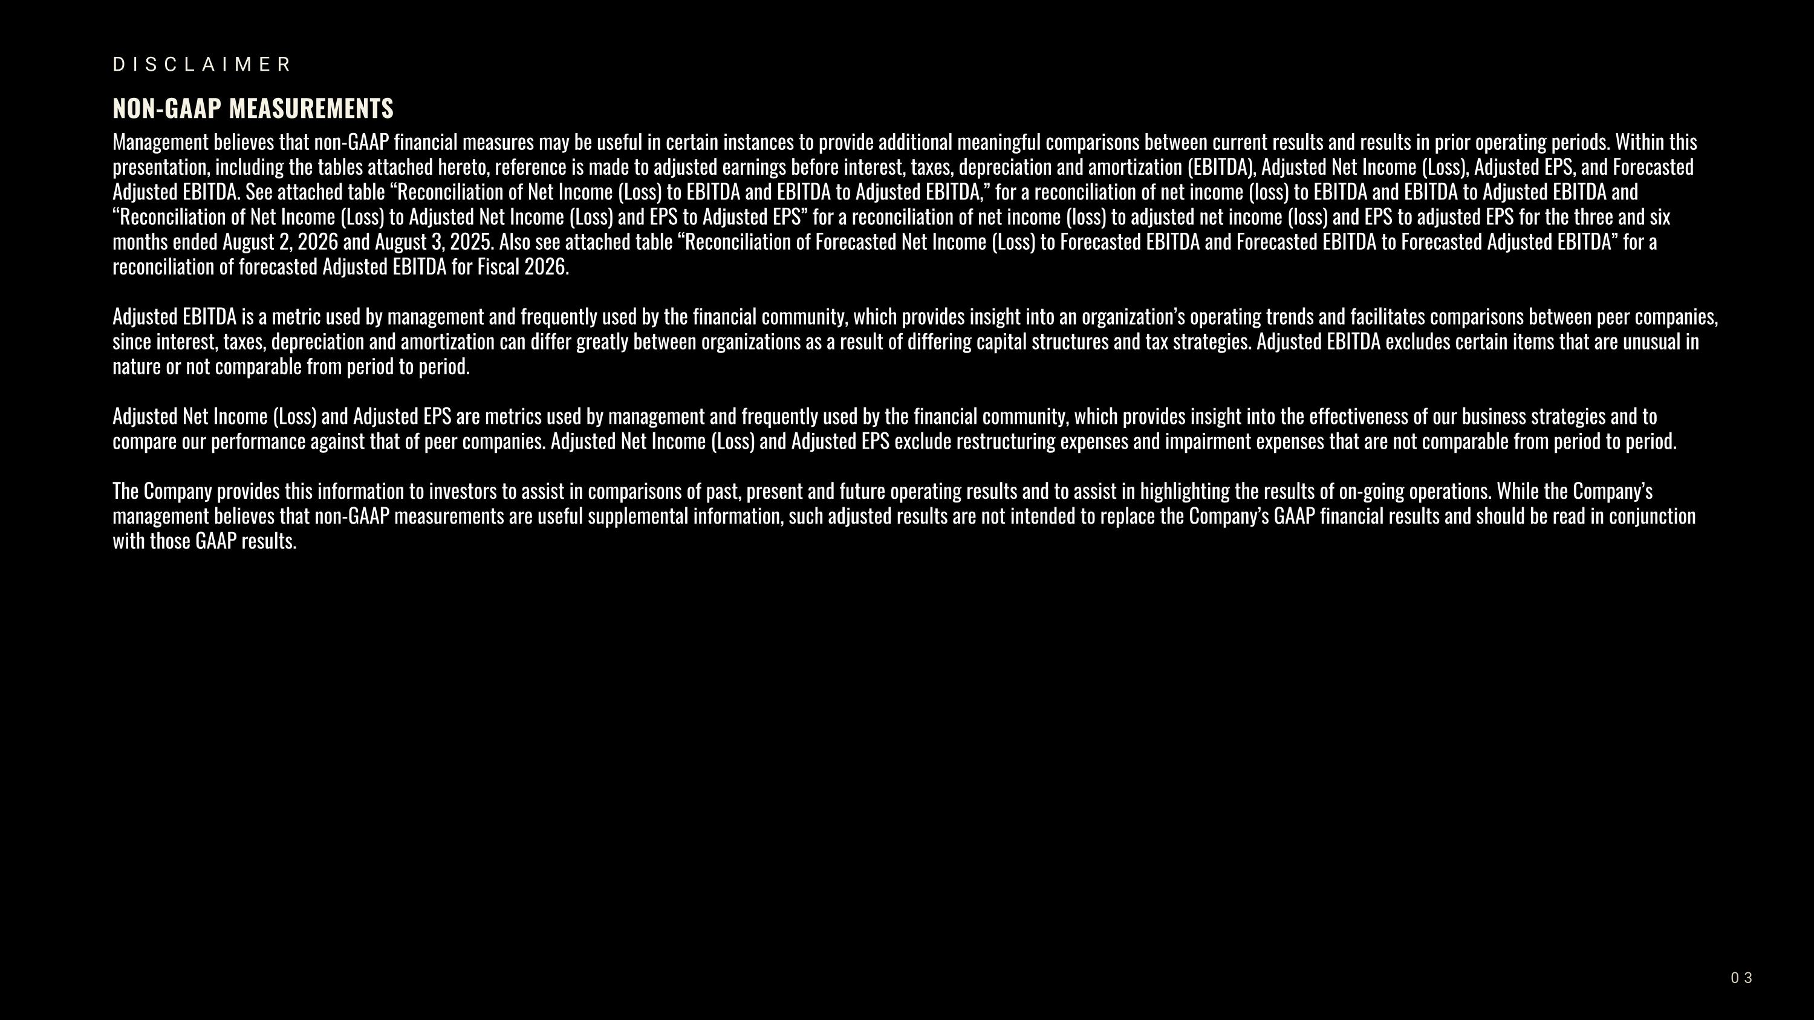
DISCLAIMER NON-GAAP MEASUREMENTS Management believes that non-GAAP financial measures may be useful in certain instances to provide additional meaningful comparisons between current results and results in prior operating periods. Within this presentation, including the tables attached hereto, reference is made to adjusted earnings before interest, taxes, depreciation and amortization (EBITDA), Adjusted Net Income (Loss), Adjusted EPS, and Forecasted Adjusted EBITDA. See attached table “Reconciliation of Net Income (Loss) to EBITDA and EBITDA to Adjusted EBITDA,” for a reconciliation of net income (loss) to EBITDA and EBITDA to Adjusted EBITDA and “Reconciliation of Net Income (Loss) to Adjusted Net Income (Loss) and EPS to Adjusted EPS” for a reconciliation of net income (loss) to adjusted net income (loss) and EPS to adjusted EPS for the three and six months ended August 2, 2026 and August 3, 2025. Also see attached table “Reconciliation of Forecasted Net Income (Loss) to Forecasted EBITDA and Forecasted EBITDA to Forecasted Adjusted EBITDA” for a reconciliation of forecasted Adjusted EBITDA for Fiscal 2026. Adjusted EBITDA is a metric used by management and frequently used by the financial community, which provides insight into an organization’s operating trends and facilitates comparisons between peer companies, since interest, taxes, depreciation and amortization can differ greatly between organizations as a result of differing capital structures and tax strategies. Adjusted EBITDA excludes certain items that are unusual in nature or not comparable from period to period. Adjusted Net Income (Loss) and Adjusted EPS are metrics used by management and frequently used by the financial community, which provides insight into the effectiveness of our business strategies and to compare our performance against that of peer companies. Adjusted Net Income (Loss) and Adjusted EPS exclude restructuring expenses and impairment expenses that are not comparable from period to period. The Company provides this information to investors to assist in comparisons of past, present and future operating results and to assist in highlighting the results of on-going operations. While the Company’s management believes that non-GAAP measurements are useful supplemental information, such adjusted results are not intended to replace the Company’s GAAP financial results and should be read in conjunction with those GAAP results. 03


INTRODUCTION TO DULUTH TRADING COMPANY 04


INTRODUCTION TO DULUTH TRADING COMPANY WHO WE ARE The Official Outfitter of Doers. We exist to champion the hands-on way of life. We build high-quality gear for hands-on folks who measure value by how long something lasts — not how much it costs. We are a No Bull Brand. We do what we say and make it right if we miss the mark. We poke average in the eye by finding a better way to create solution-based products for our customers. 05 66 STORES ACROSS?32 STATES


01 PRODUCT IS OUR PASSION. 02 THE CUSTOMER IS OUR COMPASS. 03 PEOPLE SET US APART. 04 ONWARD. ALWAYS. 05 WE POKE AVERAGE IN THE EYE. 06 OUR FIVE WELDS INTRODUCTION TO DULUTH TRADING COMPANY

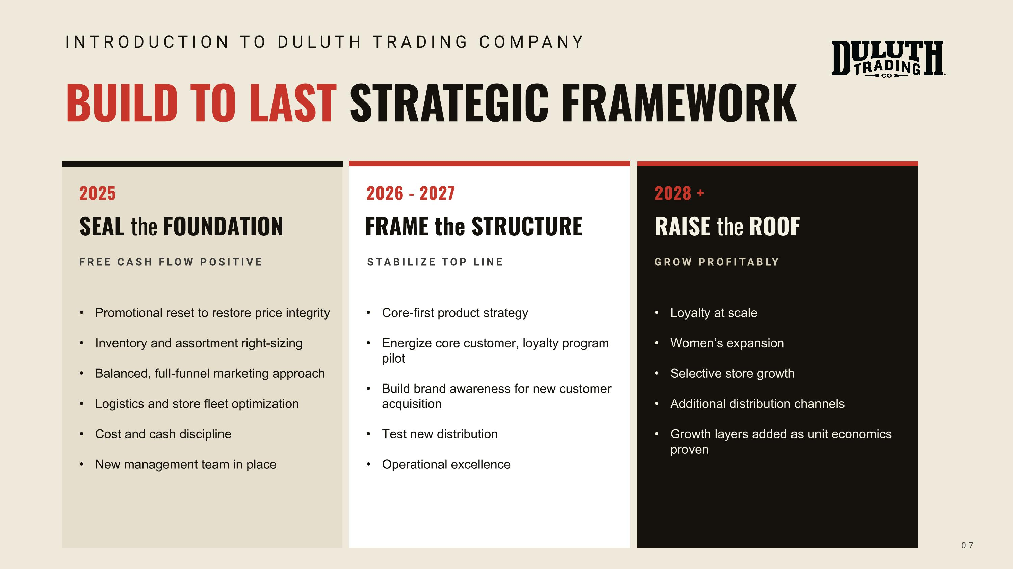
BUILD TO LAST STRATEGIC FRAMEWORK 2025 SEAL the FOUNDATION FREE CASH FLOW POSITIVE Promotional reset to restore price integrity Inventory and assortment right-sizing Balanced, full-funnel marketing approach Logistics and store fleet optimization Cost and cash discipline New management team in place 2028 + RAISE the ROOF GROW PROFITABLY Loyalty at scale Women’s expansion Selective store growth Additional distribution channels Growth layers added as unit economics proven 07 2026 — 2027 FRAME the STRUCTURE STABILIZE TOP LINE Core-first product strategy Energize core customer, loyalty program pilot Build brand awareness for new customer acquisition Test new distribution Operational excellence FRAME the STRUCTURE STABILIZE TOP LINE 2026 - 2027 INTRODUCTION TO DULUTH TRADING COMPANY

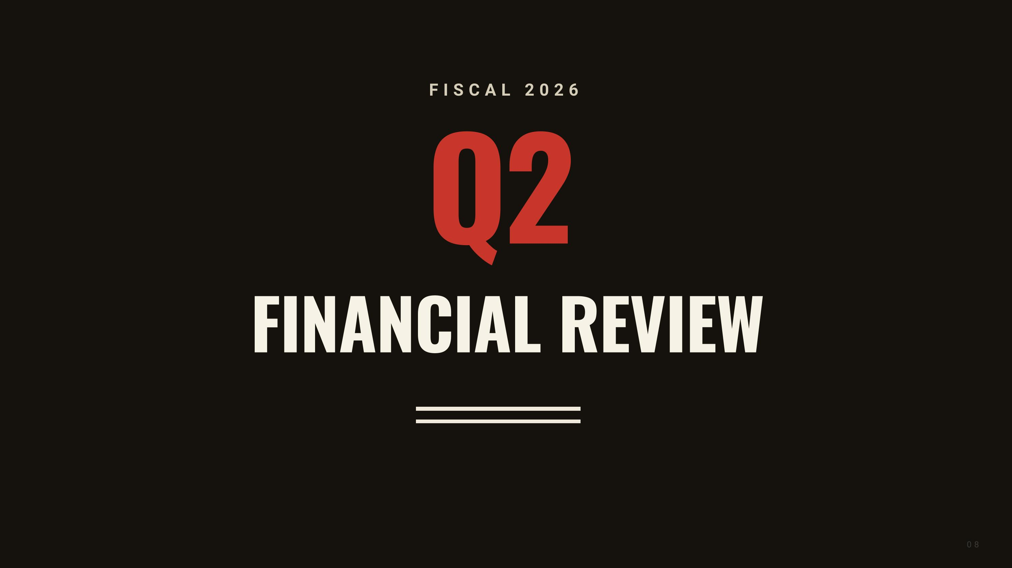
Q2 FINANCIAL REVIEW FISCAL 2026 08


EARNINGS PER SHARE 1 Reported and adjusted EPS of $0.50. This includes a $0.44 impact from tariff refunds. FISCAL 2026 SECOND QUARTER?SUMMARY 09 NET INCOME Net income of $18.4 million compared to net income of $1.3 million in the prior year second quarter. This includes the impact of $16.3 million in tariff refunds. INVENTORY Inventory down $22.9 million or 15.5% vs. last year. NET LIQUIDITY Cash and cash equivalents of $26.8 million with net liquidity of $96.1 million. ADJUSTED EBITDA 2 Adjusted EBITDA of $27.0 million compared to $12.0 million in the prior year second quarter. This includes the impact of $16.3 million in tariff refunds. QUARTER ENDED AUGUST 2, 2026 1 See Reconciliation of net income / (loss) to adjusted net income / (loss) and adjusted net income / (loss) to adjusted EPS on slide 15 2 See Reconciliation of net income / (loss) to EBITDA and EBITDA to Adjusted EBITDA on slide 15

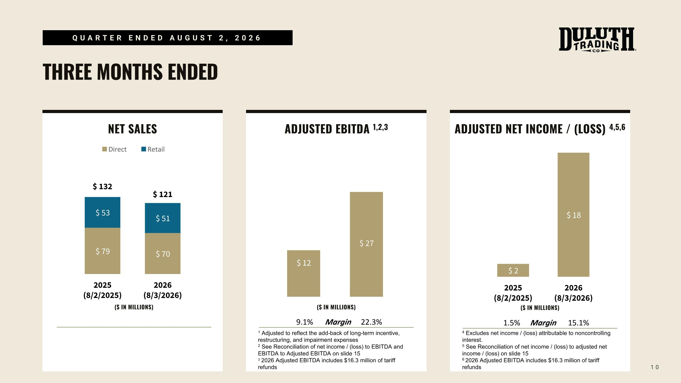
NET SALES THREE MONTHS ENDED 10 ADJUSTED EBITDA 1,2,3 1 Adjusted to reflect the add-back of long-term incentive, restructuring, and impairment expenses 2 See Reconciliation of net income / (loss) to EBITDA and EBITDA to Adjusted EBITDA on slide 15 3 2026 Adjusted EBITDA includes $16.3 million of tariff refunds ADJUSTED NET INCOME / (LOSS) 4,5,6 4 Excludes net income / (loss) attributable to noncontrolling interest. 5 See Reconciliation of net income / (loss) to adjusted net income / (loss) on slide 15 6 2026 Adjusted EBITDA includes $16.3 million of tariff refunds QUARTER ENDED AUGUST 2, 2026 ($ IN MILLIONS) ($ IN MILLIONS) ($ IN MILLIONS) 9.1% Margin 22.3% 1.5% Margin 15.1%

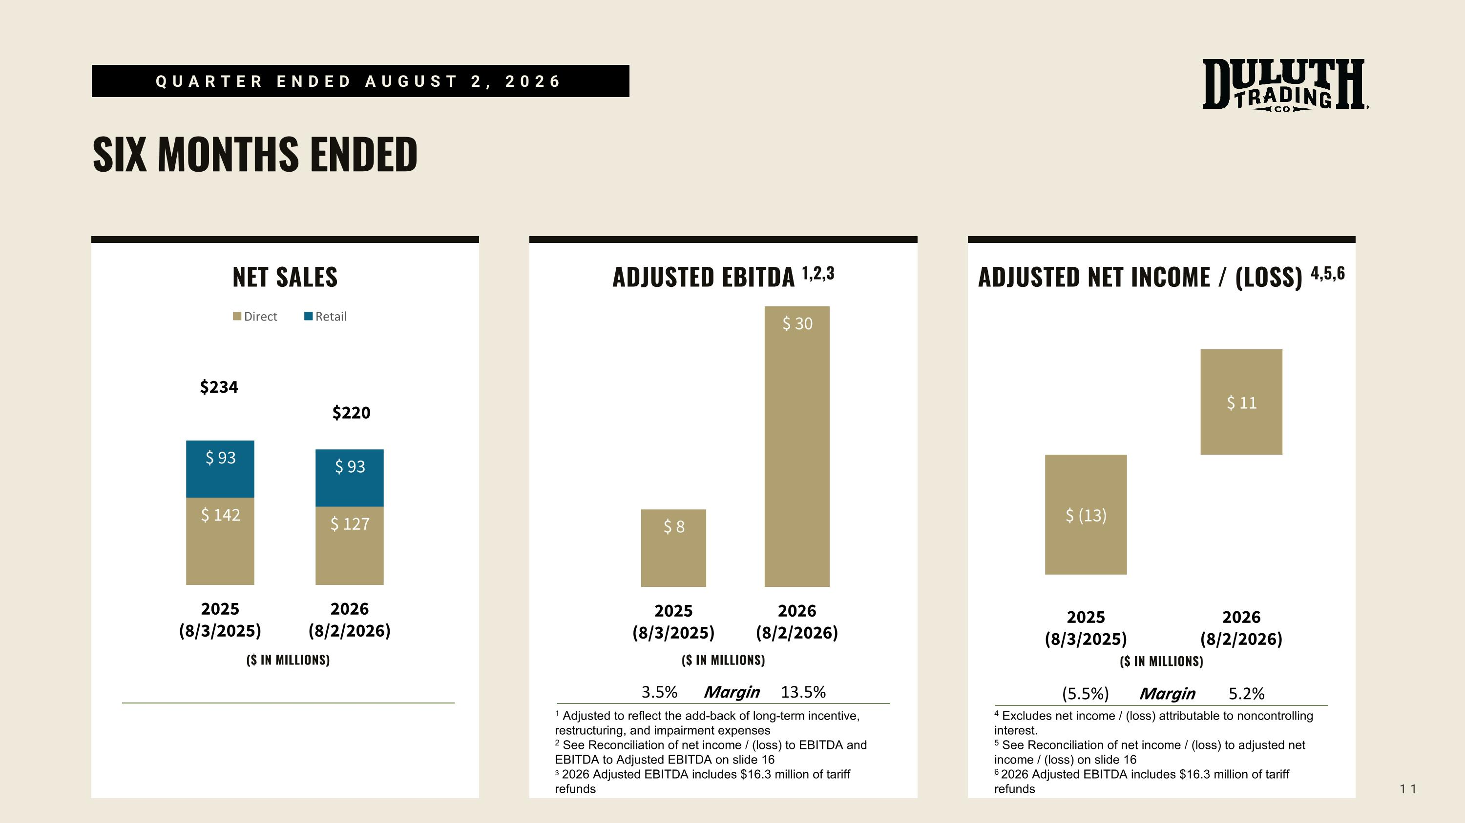
NET SALES SIX MONTHS ENDED 11 ADJUSTED EBITDA 1,2,3 ADJUSTED NET INCOME / (LOSS) 4,5,6 QUARTER ENDED AUGUST 2, 2026 ($ IN MILLIONS) ($ IN MILLIONS) ($ IN MILLIONS) 3.5% Margin 13.5% (5.5%) Margin 5.2% 1 Adjusted to reflect the add-back of long-term incentive, restructuring, and impairment expenses 2 See Reconciliation of net income / (loss) to EBITDA and EBITDA to Adjusted EBITDA on slide 16 3 2026 Adjusted EBITDA includes $16.3 million of tariff refunds 4 Excludes net income / (loss) attributable to noncontrolling interest. 5 See Reconciliation of net income / (loss) to adjusted net income / (loss) on slide 16 6 2026 Adjusted EBITDA includes $16.3 million of tariff refunds

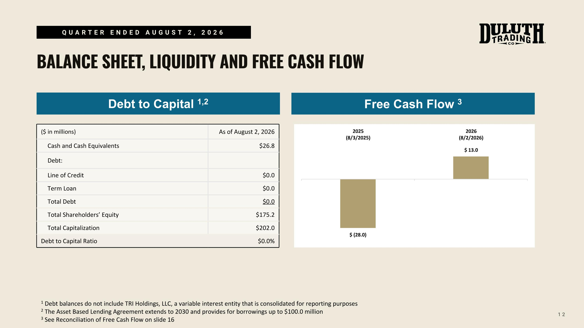
12 QUARTER ENDED AUGUST 2, 2026 BALANCE SHEET, LIQUIDITY AND FREE CASH FLOW Debt to Capital 1,2 ($ in millions) As of August 2, 2026 Cash and Cash Equivalents $26.8 Debt: Line of Credit $0.0 Term Loan $0.0 Total Debt $0.0 Total Shareholders’ Equity $175.2 Total Capitalization $202.0 Debt to Capital Ratio $0.0% Free Cash Flow 3 1 Debt balances do not include TRI Holdings, LLC, a variable interest entity that is consolidated for reporting purposes 2 The Asset Based Lending Agreement extends to 2030 and provides for borrowings up to $100.0 million 3 See Reconciliation of Free Cash Flow on slide 16

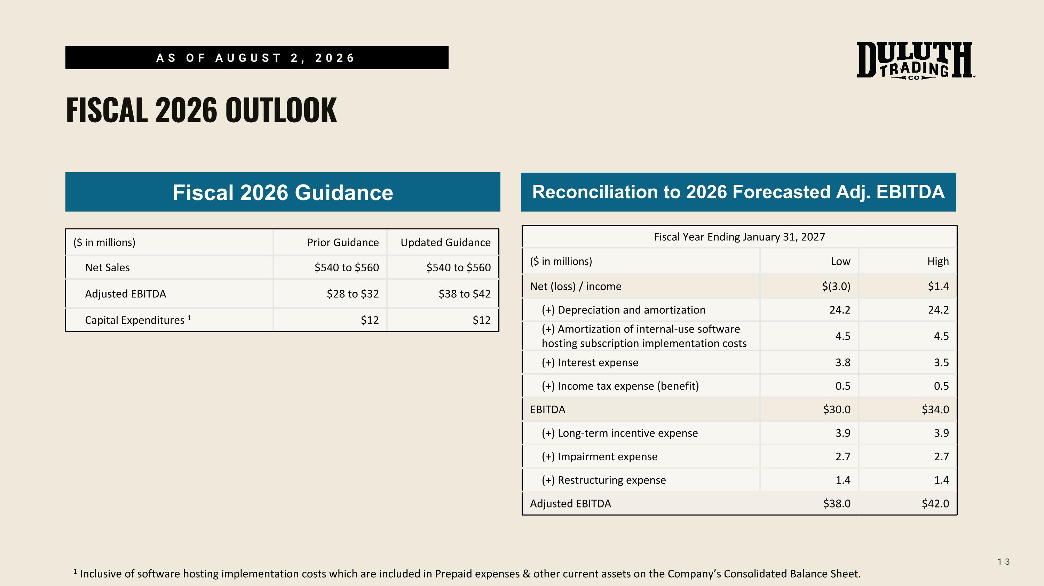
13 AS OF AUGUST 2, 2026 FISCAL 2026 OUTLOOK Fiscal 2026 Guidance Reconciliation to 2026 Forecasted Adj. EBITDA 1 Inclusive of software hosting implementation costs which are included in Prepaid expenses & other current assets on the Company’s Consolidated Balance Sheet. Fiscal Year Ending January 31, 2027 ($ in millions) Low High Net (loss) / income $(3.0) $1.4 (+) Depreciation and amortization 24.2 24.2 (+) Amortization of internal-use software hosting subscription implementation costs 4.5 4.5 (+) Interest expense 3.8 3.5 (+) Income tax expense (benefit) 0.5 0.5 EBITDA $30.0 $34.0 (+) Long-term incentive expense 3.9 3.9 (+) Impairment expense 2.7 2.7 (+) Restructuring expense 1.4 1.4 Adjusted EBITDA $38.0 $42.0 ($ in millions) Prior Guidance Updated Guidance Net Sales $540 to $560 $540 to $560 Adjusted EBITDA $28 to $32 $38 to $42 Capital Expenditures 1 $12 $12


THANK YOU

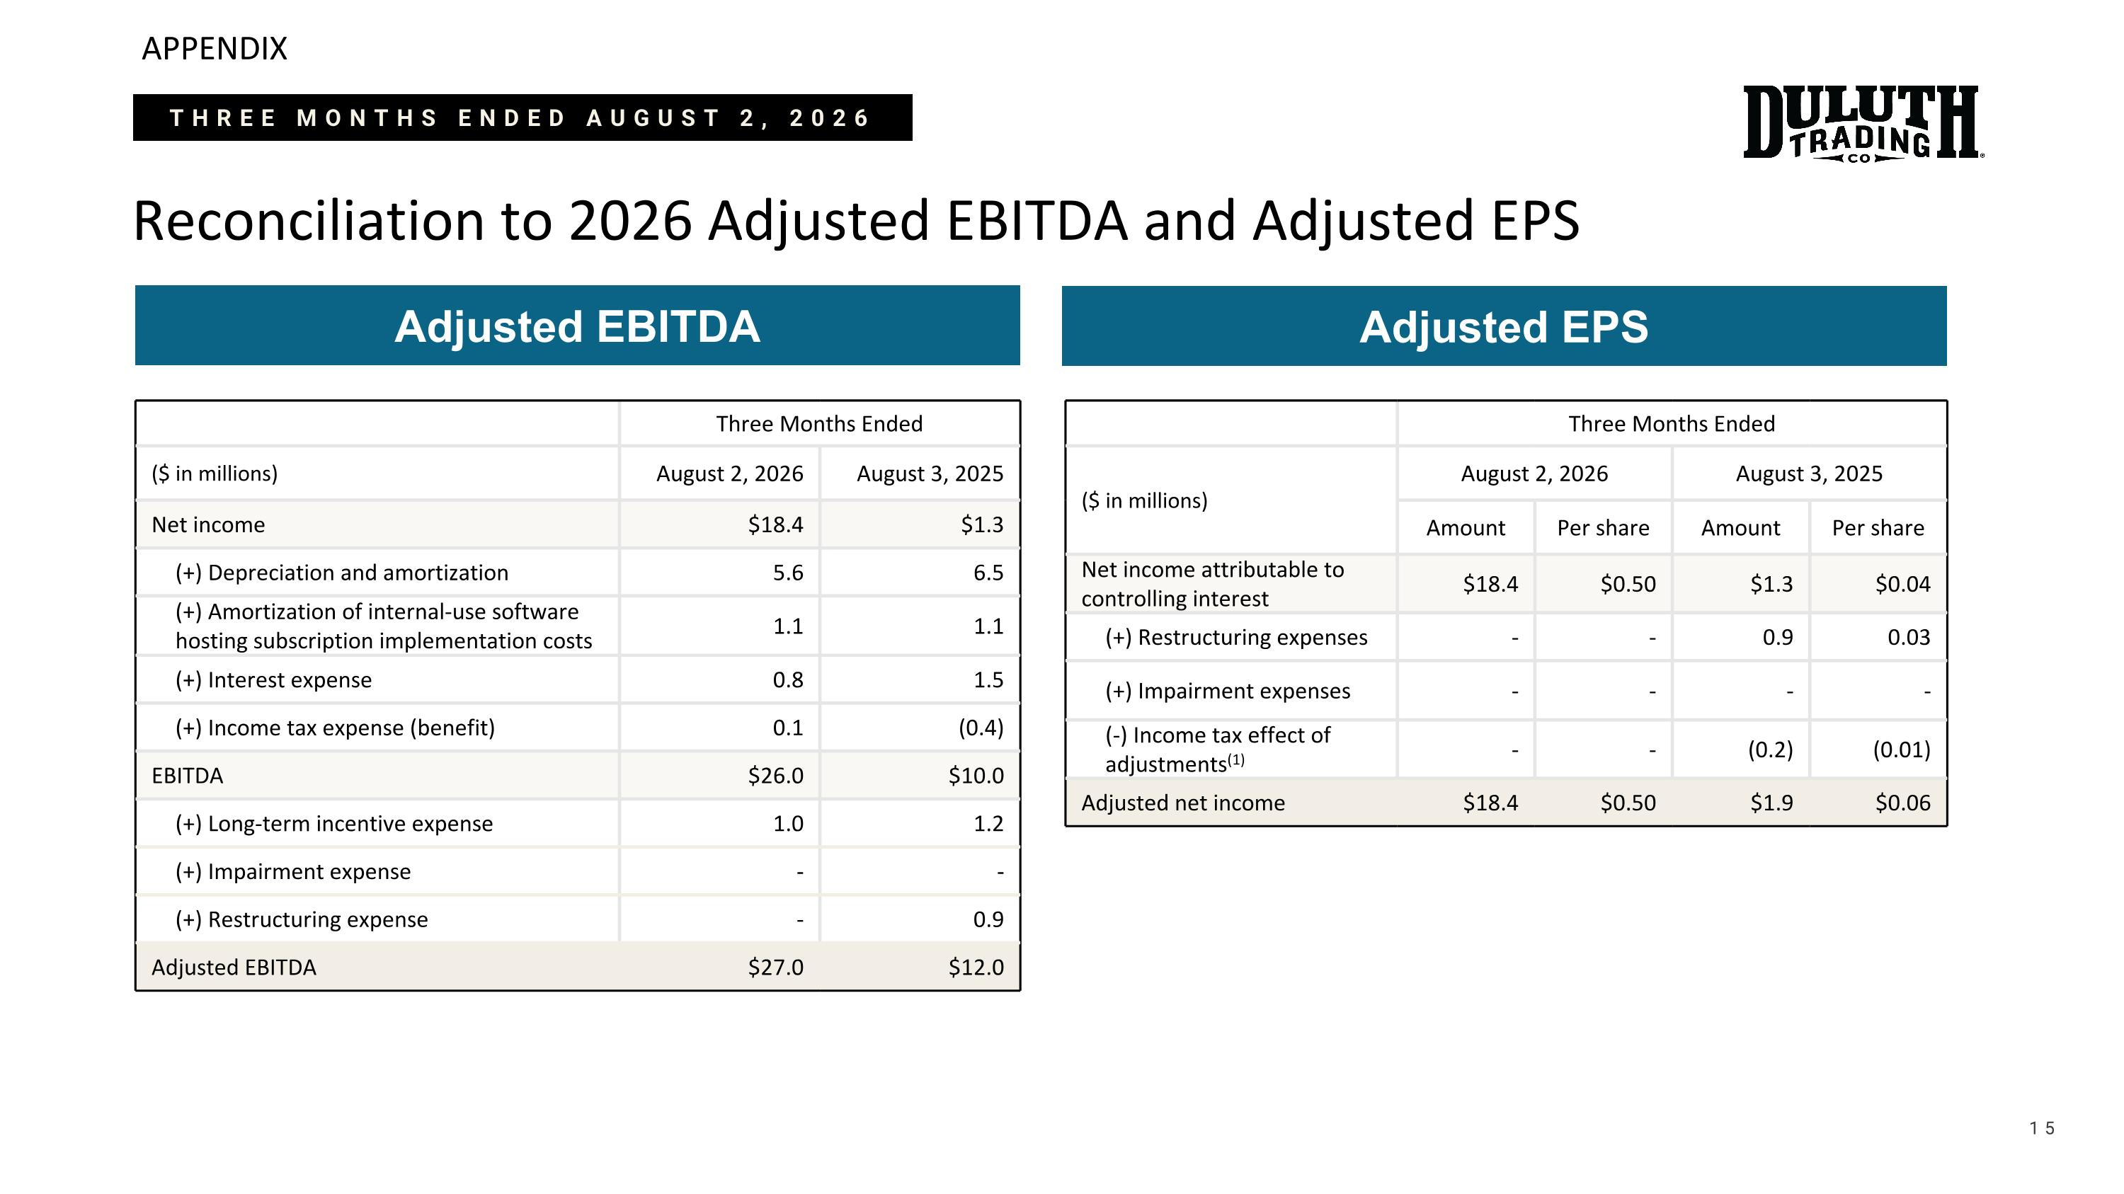
APPENDIX Reconciliation to 2026 Adjusted EBITDA and Adjusted EPS 15 Adjusted EBITDA Three Months Ended ($ in millions) August 2, 2026 August 3, 2025 Net income $18.4 $1.3 (+) Depreciation and amortization 5.6 6.5 (+) Amortization of internal-use software hosting subscription implementation costs 1.1 1.1 (+) Interest expense 0.8 1.5 (+) Income tax expense (benefit) 0.1 (0.4) EBITDA $26.0 $10.0 (+) Long-term incentive expense 1.0 1.2 (+) Impairment expense - - (+) Restructuring expense - 0.9 Adjusted EBITDA $27.0 $12.0 Adjusted EPS Three Months Ended ($ in millions) August 2, 2026 August 3, 2025 Amount Per share Amount Per share Net income attributable to controlling interest $18.4 $0.50 $1.3 $0.04 (+) Restructuring expenses - - 0.9 0.03 (+) Impairment expenses - - - - (-) Income tax effect of adjustments(1) - - (0.2) (0.01) Adjusted net income $18.4 $0.50 $1.9 $0.06 THREE MONTHS ENDED AUGUST 2, 2026

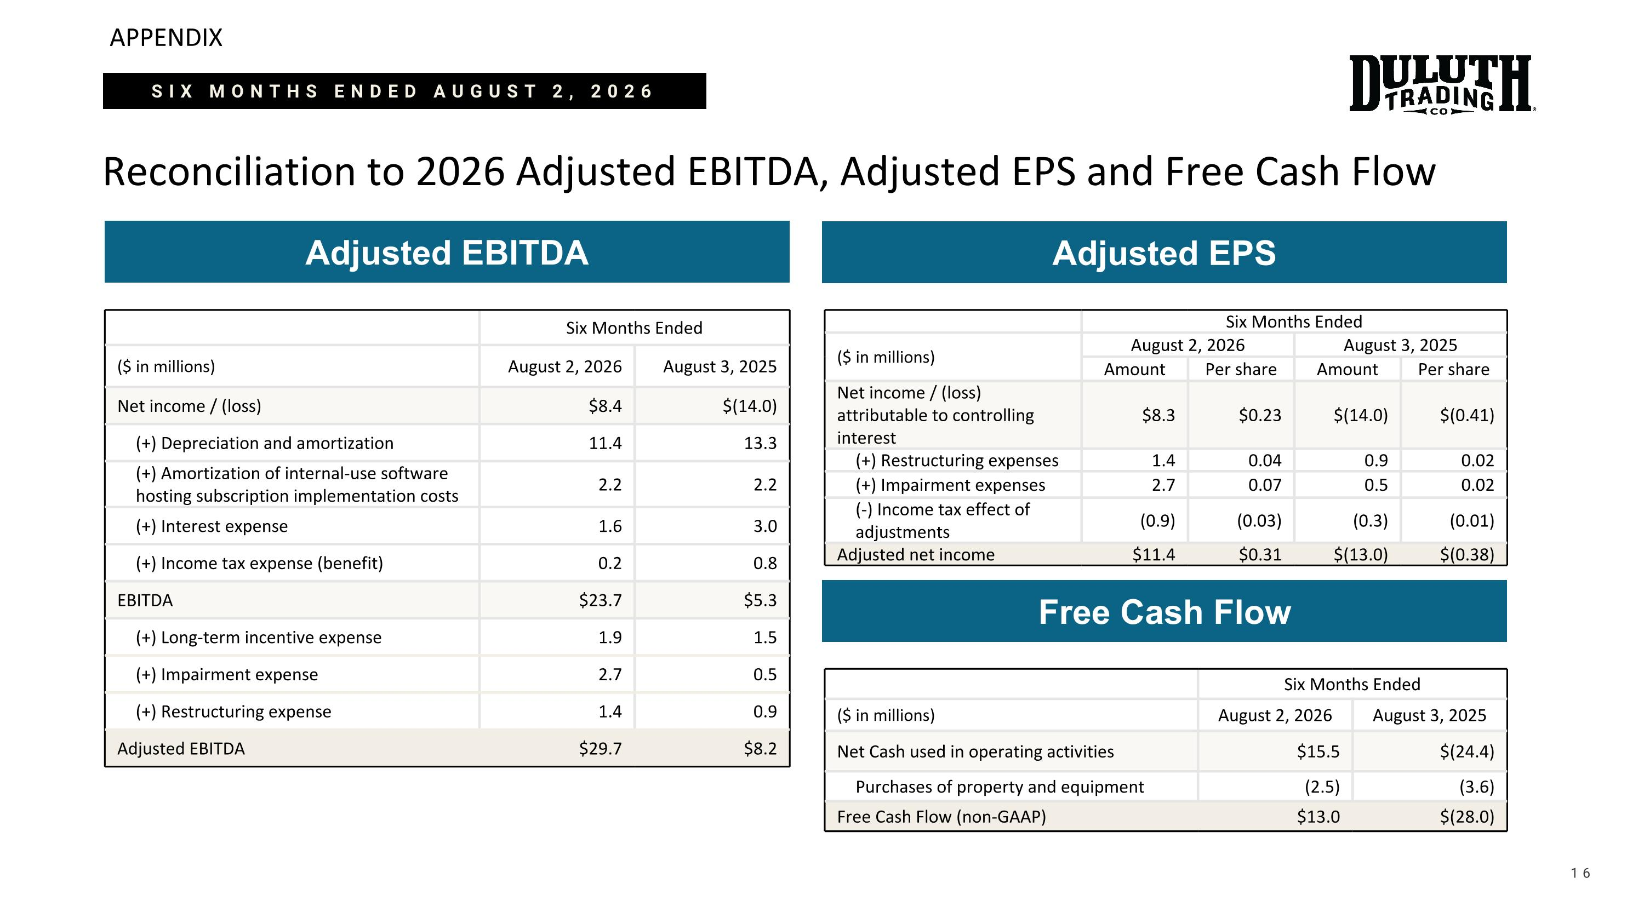
APPENDIX Reconciliation to 2026 Adjusted EBITDA, Adjusted EPS and Free Cash Flow 16 Adjusted EBITDA Six Months Ended ($ in millions) August 2, 2026 August 3, 2025 Net income / (loss) $8.4 $(14.0) (+) Depreciation and amortization 11.4 13.3 (+) Amortization of internal-use software hosting subscription implementation costs 2.2 2.2 (+) Interest expense 1.6 3.0 (+) Income tax expense (benefit) 0.2 0.8 EBITDA $23.7 $5.3 (+) Long-term incentive expense 1.9 1.5 (+) Impairment expense 2.7 0.5 (+) Restructuring expense 1.4 0.9 Adjusted EBITDA $29.7 $8.2 Adjusted EPS Six Months Ended ($ in millions) August 2, 2026 August 3, 2025 Amount Per share Amount Per share Net income / (loss) attributable to controlling interest $8.3 $0.23 $(14.0) $(0.41) (+) Restructuring expenses 1.4 0.04 0.9 0.02 (+) Impairment expenses 2.7 0.07 0.5 0.02 (-) Income tax effect of adjustments (0.9) (0.03) (0.3) (0.01) Adjusted net income $11.4 $0.31 $(13.0) $(0.38) SIX MONTHS ENDED AUGUST 2, 2026 Free Cash Flow Six Months Ended ($ in millions) August 2, 2026 August 3, 2025 Net Cash used in operating activities $15.5 $(24.4) Purchases of property and equipment (2.5) (3.6) Free Cash Flow (non-GAAP) $13.0 $(28.0)

